**Creating Service Accounts**

**What are service accounts?**

A service account is a special Google account that belongs to your application or a virtual machine (VM) instead of an individual end user. Your application uses the service account to call the *Google API of a service*, so that the users aren't directly involved.

For example, a Compute Engine VM may run as a service account, and that account can be given permissions to access the resources it needs. This way the service account is the identity of the service, and the service account's permissions control which resources the service can access. A service account is identified by its email address, which is unique to the account.

1. Once you first log in, your screen should look similar to this.

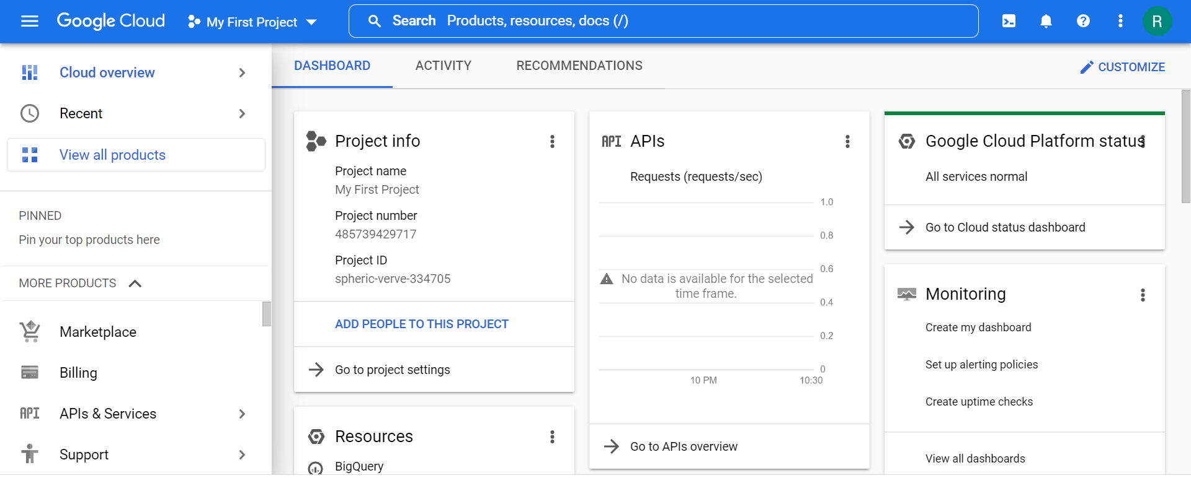

1. Click on the project selector drop-down menu at the top of the screen.

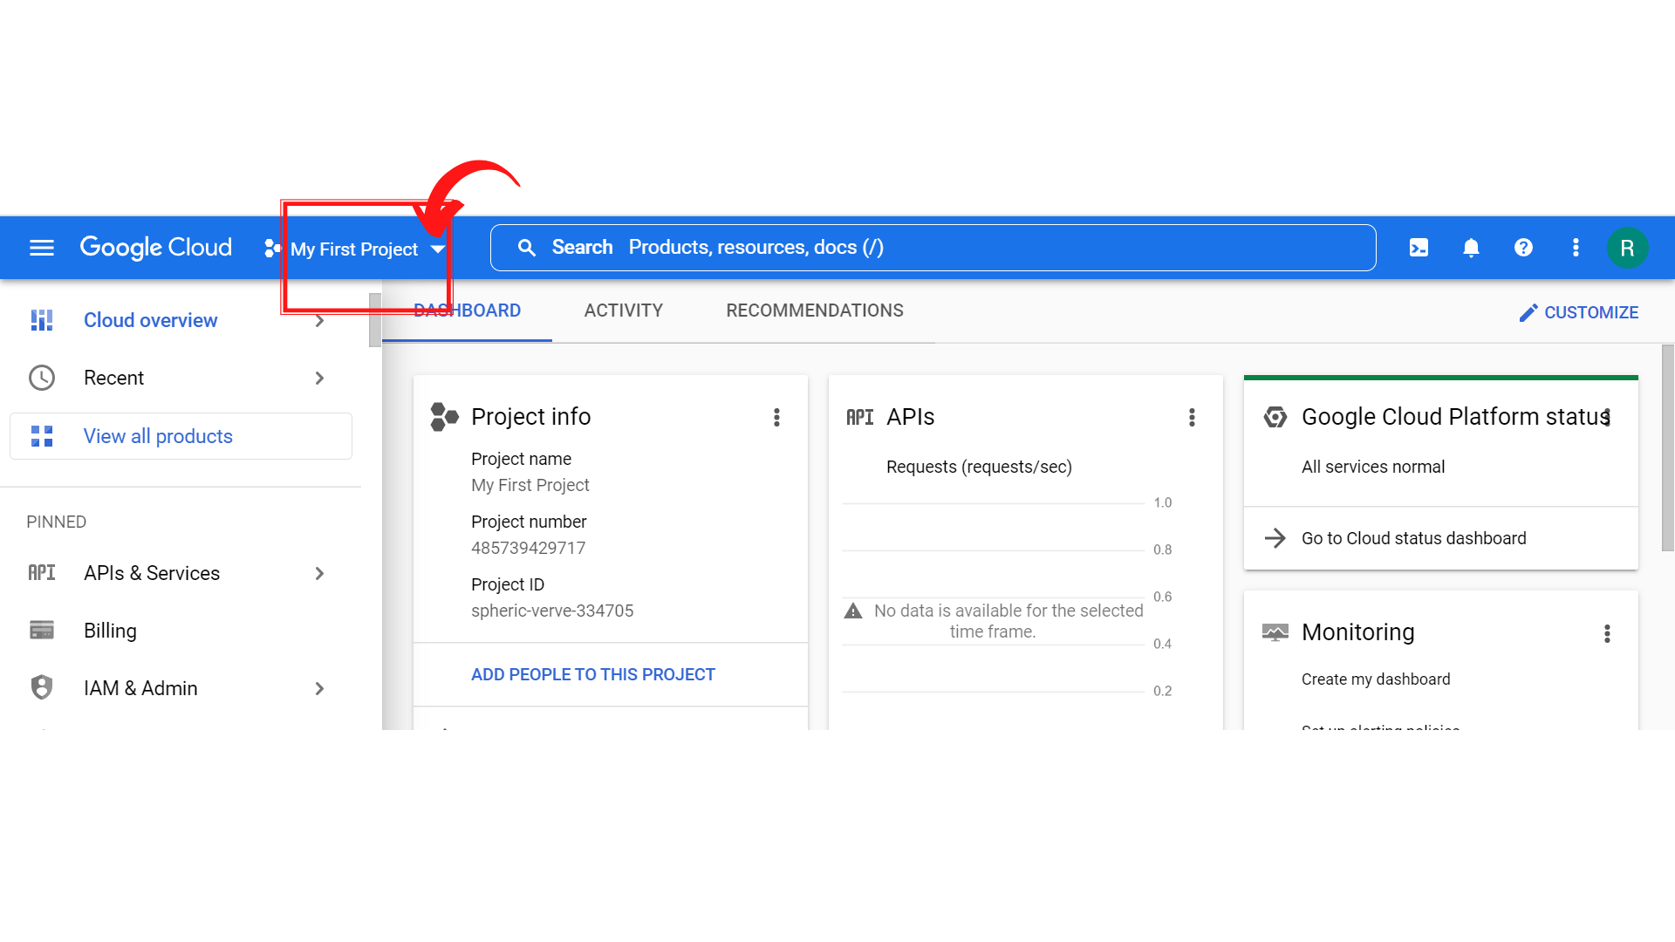

1. Since, we are doing labs on a Security Labs project, Click on *“Security Labs”*.

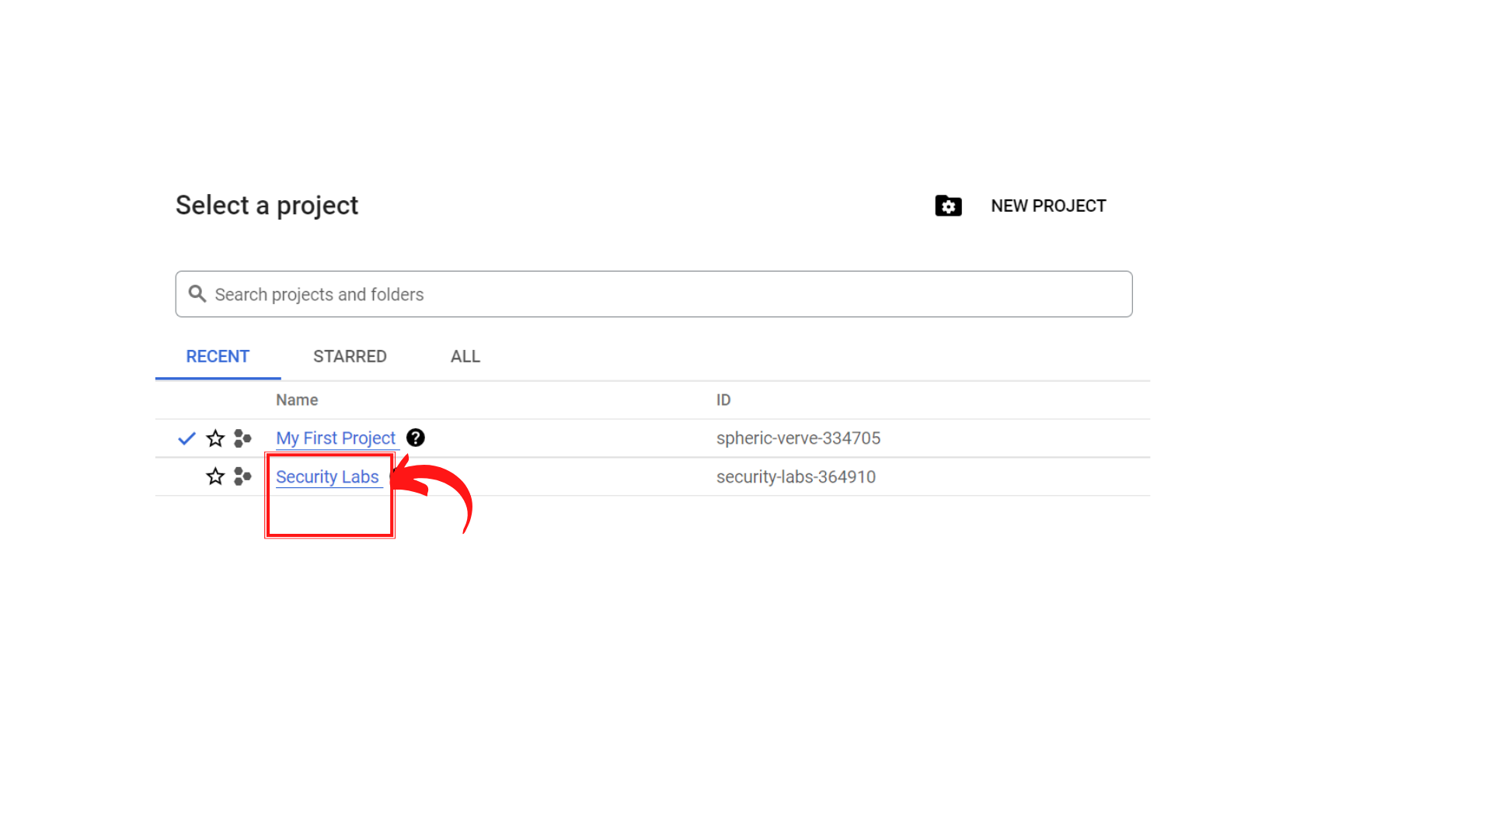

1. Your screen should look similar to this with project info changed to “*Security Labs”* project.

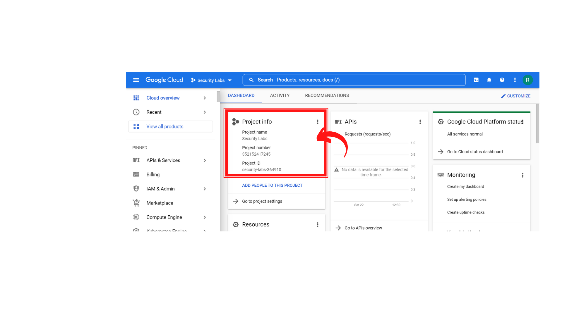

1. To create a new service account, click on “*IAM & Admin → Service Accounts”.*

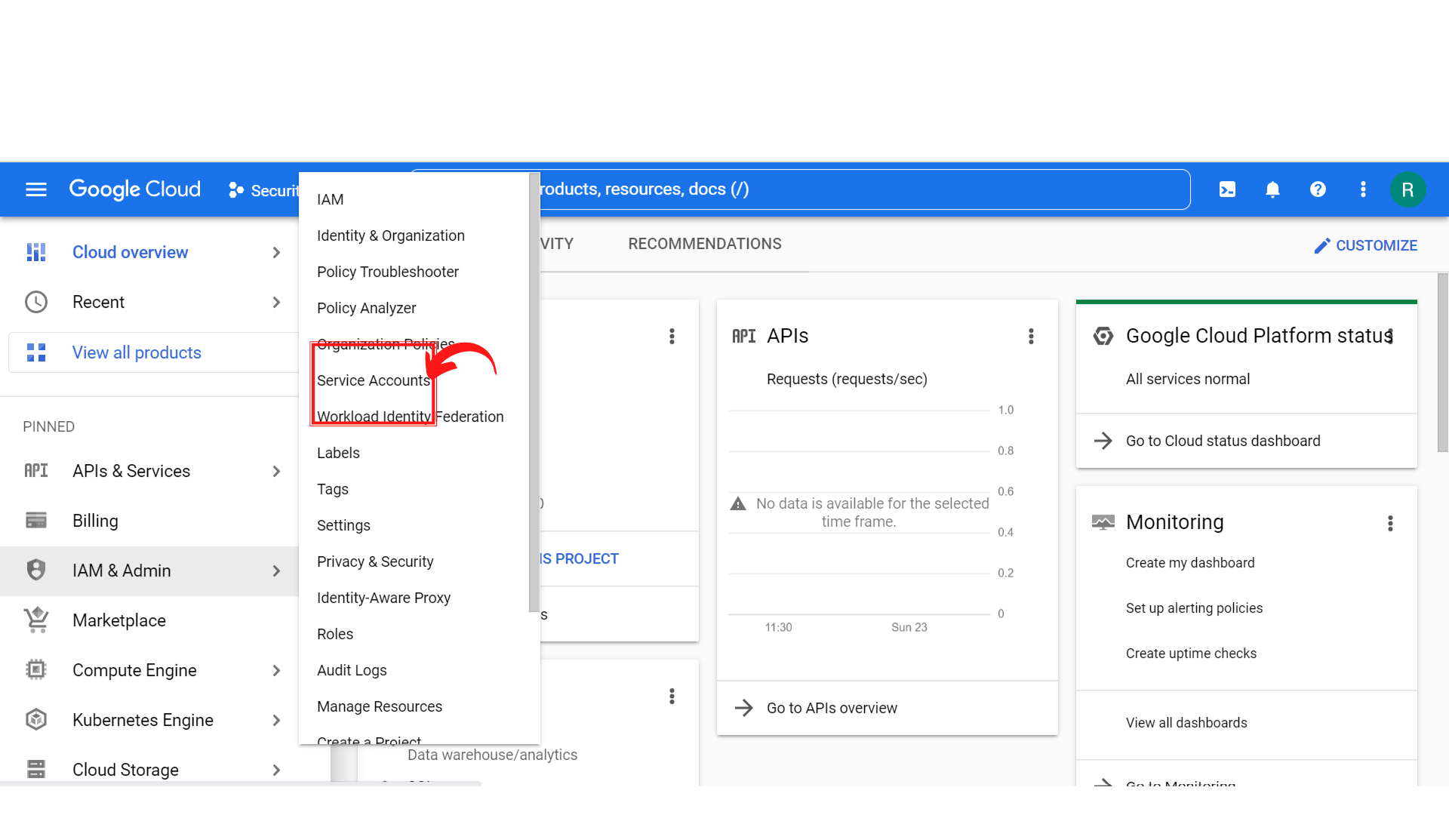

1. Your screen should look similar to this.

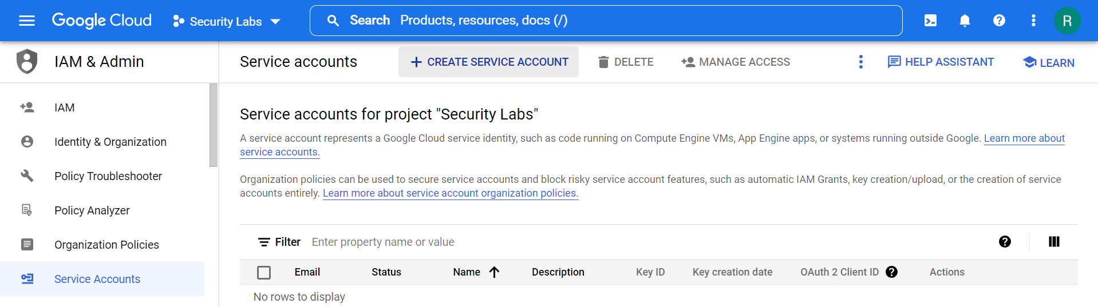

1. Click on *“Create Service Account”.*

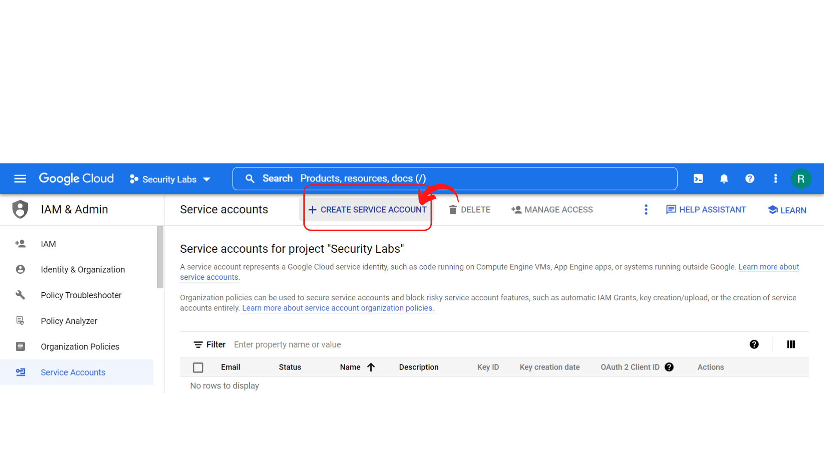

1. Your screen should look similar to this.

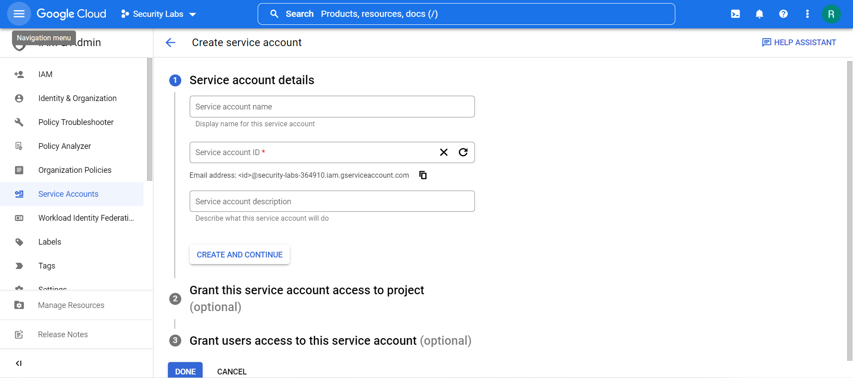

1. Fill the details like *“Service account name”* , *“Service account ID”* and *description*(if required) and then click *“Create and Continue”.*

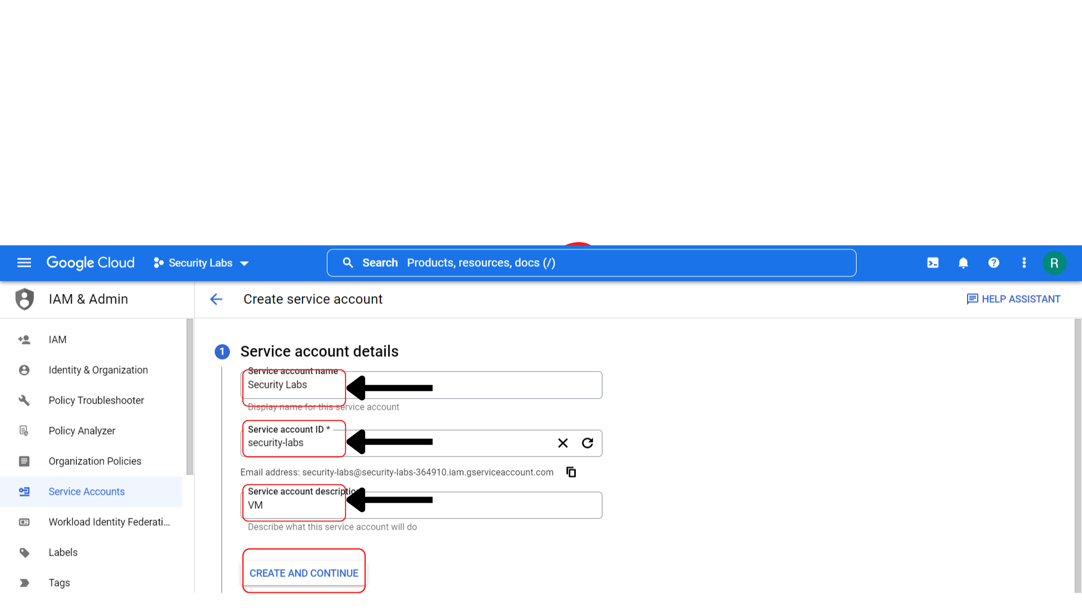

1. Your screen should look similar to this and enter the Role as you want to give permissions. Here I'm choosing Role as *Basic → Owner* and click on *“Continue”*.

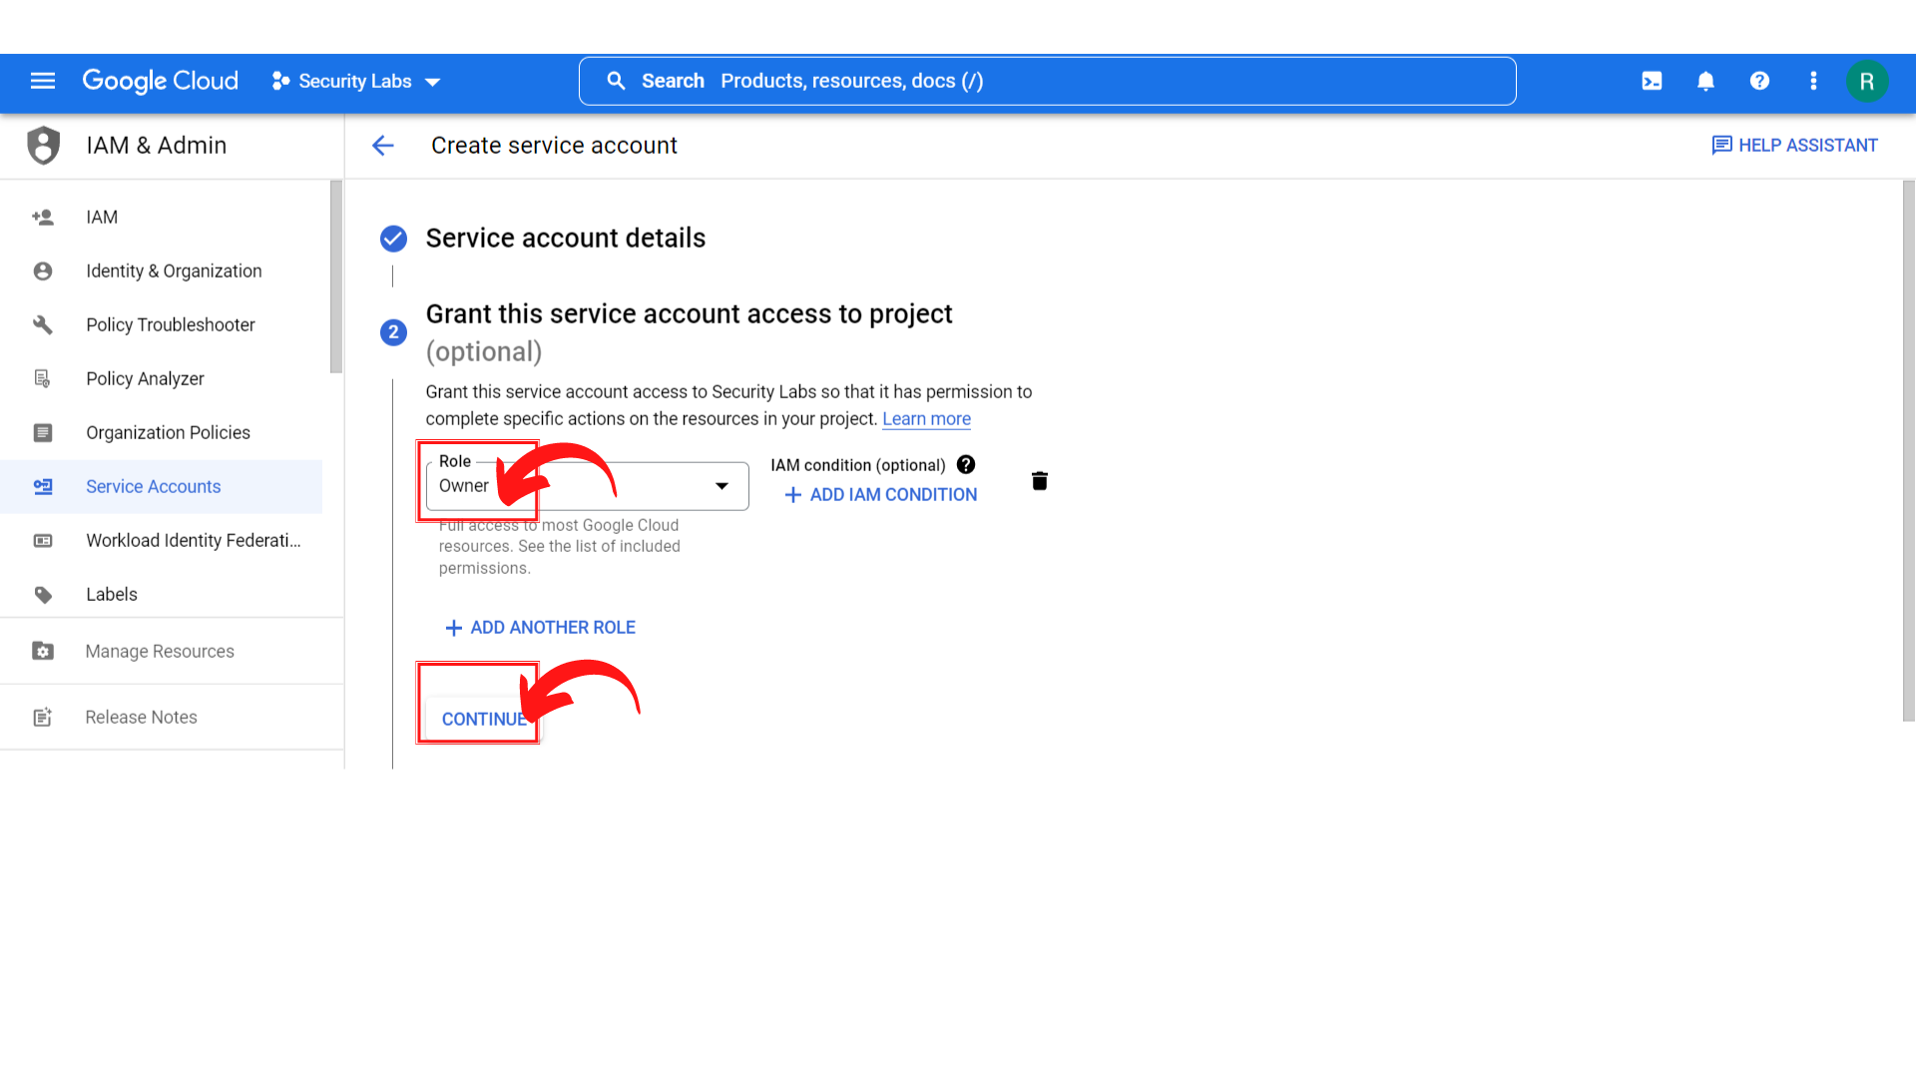

1. Your screen should look similar to this and you can assign roles to deploy jobs and VMs with this service account. Here I'm leaving it as optional and clicking on *“Done”.*

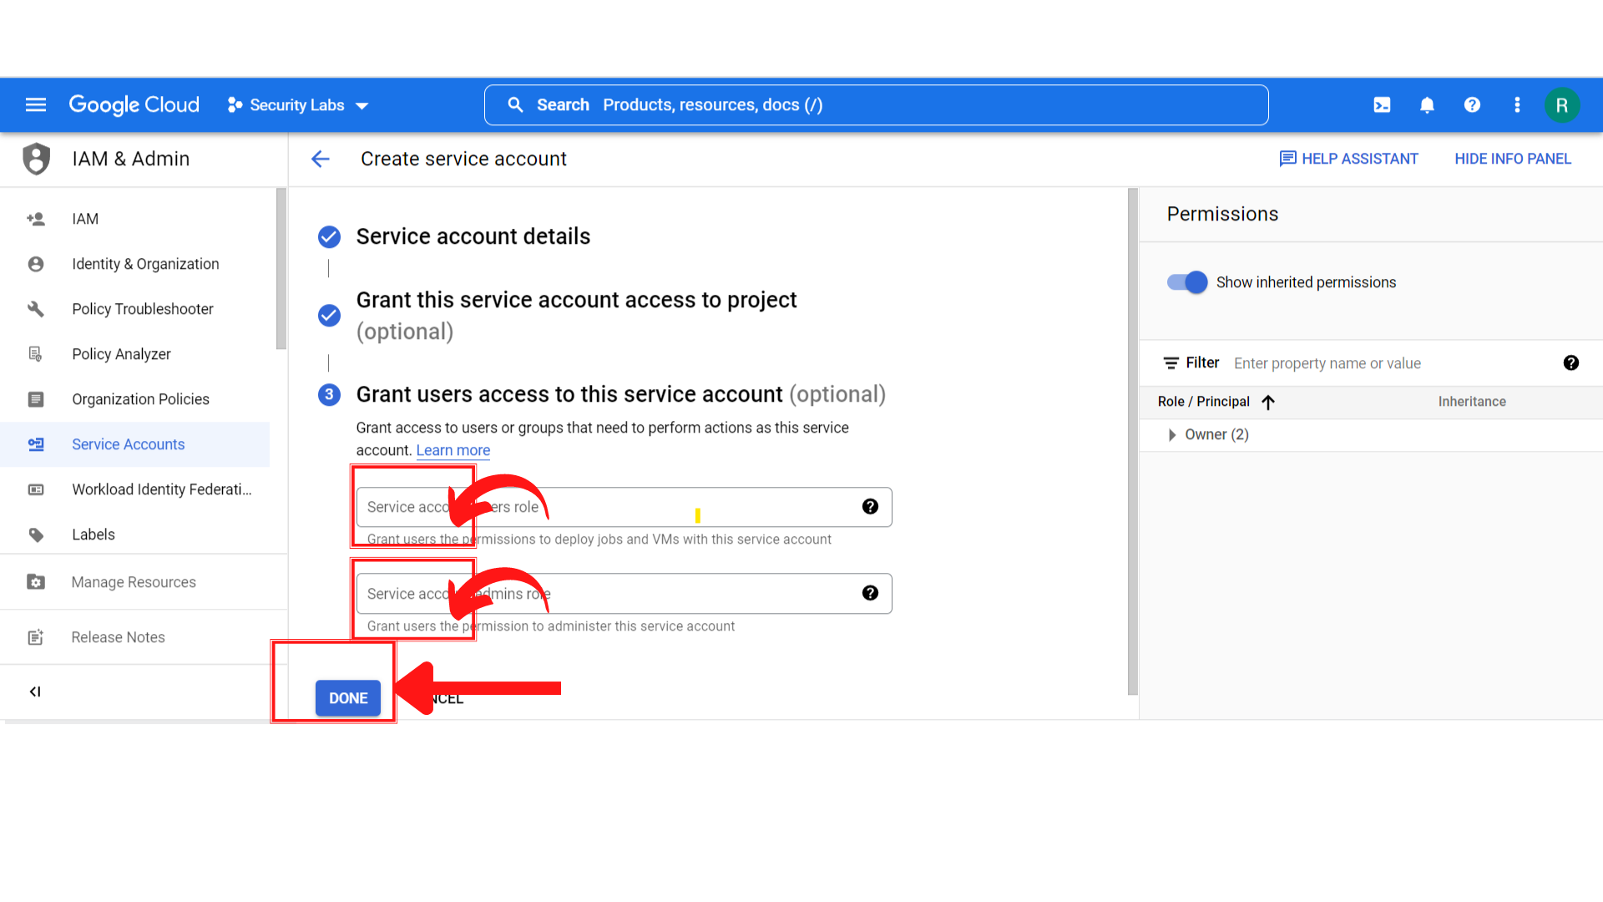

1. That’s it, A new service account is created.

